**He-Ne Laser (Gas Laser: 4 level laser system)**

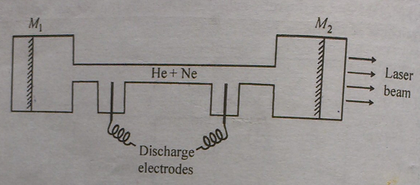

**Fig.:** Schematic of He-Ne laser (M1, M2 are the reflecting mirrors).

**Construction:**

It comprises of a gas tube containing as active material a mixture of He and Ne gas at the ratio of 10:1, at low pressure. Laser action takes place in the energy level of Ne atoms. He atoms help to archive population inversion by imparting their energy to the neon atom. The resonant cavity is formed by a partially reflecting and a totally reflecting mirror attached to two ends of the tube. Pumping is done by a DC electrical discharge in the low pressure gas in the tube. The wavelength of the laser is 632.8 nm.

**Working principle:**

The common helium-neon gas laser achieves a population inversion in a different way. A mixture of about 10 parts of helium and 1 part of neon at a low pressure (1 torr) is placed in a glass tube that has parallel mirrors, one of them partly transparent, at both ends. The spacing of the mirrors is again (as in all lasers) equal to an integral number of half-wavelengths of the laser light. An electric discharge is produced in the gas by means of electrodes outside the tube connected to a source of high-frequency alternating current, and collisions with electrons from the discharge excite He and Ne atoms to metastable states respectively 20.61 and 20.66 eV above their ground states (see the **Fig.** below). Some of the excited He atoms transfer their energy to ground-state Ne atoms in collisions, with the 0.05 eV of additional energy being provided by the kinetic energy of the atoms. The purpose of the He atoms is thus to help achieve a population inversion in the Ne atoms.

The laser transition in Ne is from the metastable state at 20.66 eV to an excited state at 18.70 eV, with the emission of a 632.8-nm photon. Then another photon is spontaneously emitted in a transition to a lower metastable state; this transition yields only incoherent light. The remaining excitation energy is lost in collisions with the tube walls. Because the electron impacts that excite the He and Ne atoms occur all the time, unlike the pulsed excitation from the xenon flash lamp in a ruby laser, a He-Ne laser operates continuously. This is the laser whose narrow red beam is used in supermarkets to read bar codes. In a He-Ne laser, only a tiny fraction (one in millions) of the atoms present participates in the laser process at any moment.

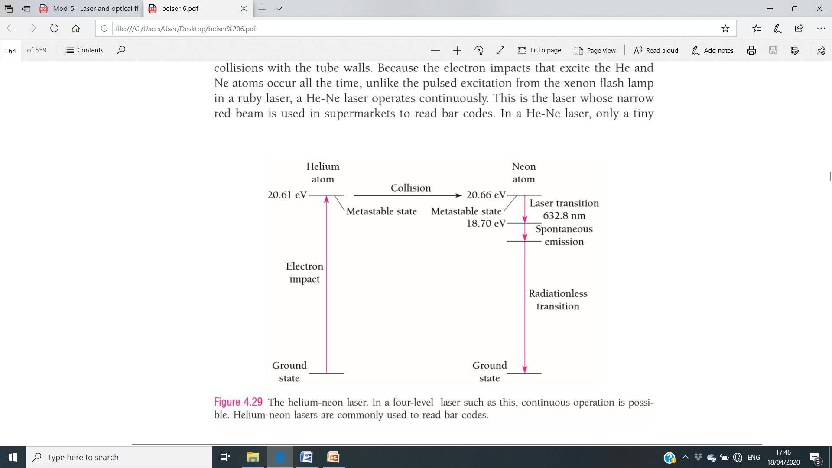

**Fig.:** The Helium-Neon laser

**Role of Helium atoms**:

Being a good conductor of heat, He acts as a coolant and no separate cooling system is required. He atoms being lighter than Ne atoms absorbs the energy from the high energy electrons easily and very fast. The ratio He : Ne=10:1 makes the probability of energy transfer for He atoms to Ne atoms much higher than that of the reverse.

**Merits:**

• Continuous output laser source

• Highly stable

• No separate cooling is required

**Demerits:**

• Low efficiency and low power output

• Gases are novel medium for laser as gases are found in the purest form so their optical properties are well defined.

**Other types of Lasers:**

Many other types of laser have been devised. A number of them employ molecules rather than atoms. **Chemical lasers** are based on the production by chemical reactions of molecules in metastable excited states. Such lasers are efficient and can be very powerful: one chemical laser, in which hydrogen and fluorine combine to form hydrogen fluoride, has generated an infrared beam of over 2 MW. Dye lasers use dye molecules whose energy levels are so close together that they can “lase” over a virtually continuous range of wavelengths. A **Dye laser** can be tuned to any desired wavelength in its range. **Nd:YAG** lasers, which use the glassy solid yttrium aluminum garnet with neodymium as an impurity, are helpful in surgery because they seal small blood vessels while cutting through tissue by vaporizing water in the path of their beams. Powerful carbon dioxide gas lasers with outputs up to many kilowatts are used industrially for the precise cutting of almost any material, including steel, and for welding.

Tiny **semiconductor lasers** by the million process and transmit information today. In a compact disk player, a semiconductor laser beam is focused to a spot a micrometer (10–6 m) across to read data coded as pits that appear as dark spots on a reflective disk 12 cm in diameter. A compact disk can store over 600 megabytes of digital data, about 1000 times as much as the floppy disks used in personal computers. If the stored data is digitized music, the playing time can be over an hour.

**Semiconductor lasers** are ideal for fiber-optic transmission lines in which the electric signals that would normally be sent along copper wires are first converted into a series of pulses according to a standard code. Lasers then turn the pulses into flashes of infrared light that travel along thin (5–50 μm diameter) glass fibers and at the other end are changed back into electric signals. Over a million telephone conversations can be carried by a single fiber; by contrast, no more than 32 conversations can be carried at the same time by a pair of wires. Telephone fiber-optic systems today link many cities and exchanges within cities everywhere, and fiber-optic cables span the world’s seas and oceans.

**Applications of Laser:**

(i) Laser is used in industry for the purpose of cutting, drilling and welding (due to narrow angular spread and high intensity)

(ii) Medical Science: microsurgery, treatment of retina, cancer treatment, laser angioplasty for clearing the blocked arteries, microsurgery (due to narrow angular spread).

(iii) Communication: micro-communication, large amount of data is transferred

(iv) Hologram: 3D imaging, both phase and amplitude are considered

(v) Distance measurement: LIDAR (light detection and ranging), distance between earth and moon can be measured by pulse echo technique

(vi) Defense: Ranging and guiding weapons. Also it is used as death ray (high antensity and highly directional)

(vii) Computer and printers (laser diode is used). Storage capacity for information in computer is improved due to narrow band width of laser light. Laser printer

(viii) Spectroscopy: Raman spectroscopy and Photoluminescence

(ix) Environmental study, electronics etc.

**Model Questions:**

1. How is laser different from ordinary light?

2. Explain briefly the terms (i) stimulated emission (ii) spontaneous emission (iii) population inversion (iv) metastable state.

3. What does the acronym LASER stand for?

4. Write two important characteristics of it.

5. Draw the population of atoms in different energy levels in atomic systems in equilibrium.

6. Population Inversion is the necessary condition for lasing action. Explain.

7. What is population inversion? Explain why population inversion cannot be achieved in two energy level system.

8. What are the necessary and sufficient conditions for lasing action?

9. Why is a narrow tube used in He-Ne laser?

10. Why the end is faces of a ruby rod silvered?

11. What is the function of He atoms in He-Ne laser?

12. What is the function of Cr+3 ions in ruby laser?

13. Write down the ratio of number of He atoms to number of Ne atoms in a typical He:Ne laser. Why such a ratio is maintained?

14. What is positive feedback in laser? Why it is called optical feedback?

15. Explain why a four-level laser is more efficient than a three-level laser.

16. Explain briefly different uses to which laser beams are put.

17. Explain construction and working of ruby laser with the help of a suitable energy level diagram. Write its limitations.

18. Explain the construction and working of He-Ne laser with the help of an energy level diagram. Write its advantage over ruby laser.

19. What does LASER stand for? Write some characteristics of laser. Describe the working of a three energy level Laser system. Mention its limitations.

20. Describe the components of a Laser system.

21. (i) Distinguish between spontaneous emission and stimulated emission. (ii) Why is population inversion referred to as a negative temperature state?

22. Explain the working of a four-level laser system with a suitable energy level diagram.

23. Draw a neat diagram to represent the component of a ruby laser. Explain the operation.

**Numerical:**

1 A Ruby laser emits light of 693.95 nm wavelength. If 1 mole of Cr+3 ions are involved in the lasing process, calculate the pulse energy in eV.

2. If the lasing wavelength in Ruby laser is 694.3 nm, what the ratio of populations of the corresponding energy levels?

3. Calculate the energy of the metastable state in a material where stimulated emission to an energy state at 0.25 eV causes emission of radiation of wavelength 1100 nm.

4. If the wavelength of laser is 632.8 nm, then find the intensity of the laser if the power delivered is 103 Watt.

5. A ruby laser has its metastable state at 1.79 eV from which stimulated emission produces laser light. At room temperature when the population inversion is not achieved, calculate the ratio of population of the atoms in the metastable state to that in the ground state.

6. In a material, transition occurs between a metastable state and an energy level of 0.45 eV and the wavelength of the radiation emitted is 2000 nm. Calculate the energy of the metastable state.

7. A laser beam of wavelength 7400Å has coherence time of 4 X 10-5 s. Determine the temporal coherence length.

8. A ruby laser has its metastable state at 1.79 eV from which stimulated emission produces laser light. Calculate the wavelength of laser light.

9. The wavelength of a He-Ne laser generating 3.14 mW power is 632.8 nm. What is the number of photons emitted per minute when it is in operation?

**OPTICAL FIBER**

Optical Fibers are thin fibers which act as waveguides to transport electromagnetic waves at optical frequencies over very long distance with very low loss of signal.

Transmission of data through optical fiber is called photonic devices (metallic wire is electronic devices)

**Structure:**

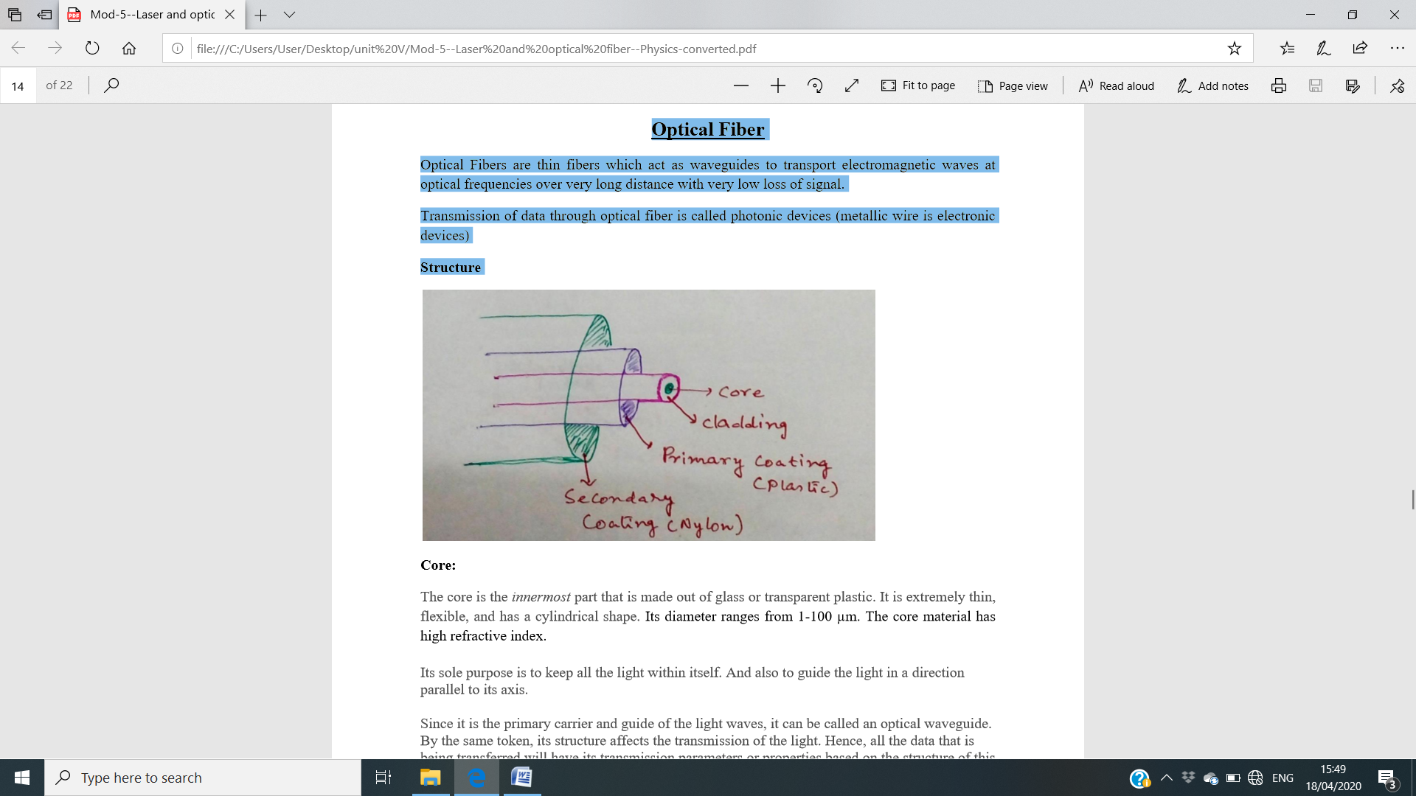

**Core:** The core is the innermost part that is made out of glass or transparent plastic. It is extremely thin, flexible, and has a cylindrical shape. Its diameter ranges from 1-100 µm. The core material has high refractive index.

Its sole purpose is to keep all the light within itself and also to guide the light in a direction parallel to its axis.

Since it is the primary carrier and guide of the light waves, it can be called an optical waveguide. By the same token, its structure affects the transmission of the light. Hence, all the data that is being transferred will have its transmission parameters or properties based on the structure of this segment of the fiber optic.

**Cladding**: It surrounds the core. The diameter ranges from 100-300 µm. It is also made of glass or transparent plastic. But with a different material, so the refractive index of the cladding is lower than that of the core.

**Coating/Jacket**: Primary (plastic) and secondary (nylon) coating

Principle of optical fiber : When light travels from a high refractive index (r.i) material to a low r.i material, the light rays can get completely reflected when angle of incident θ > θc, the critical angle of incidence. The rays travel from one to another end of the optical fiber without much attenuation (loss) through multiple reflections.

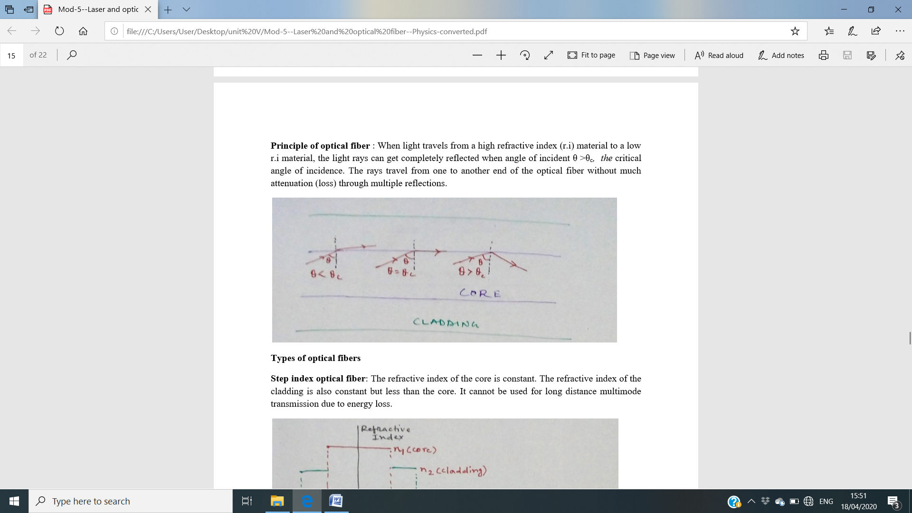

**Types of optical fibers**

**Step index optical fiber:** The refractive index of the core is constant. The refractive index of the cladding is also constant but less than the core. It cannot be used for long distance multimode transmission due to energy loss.

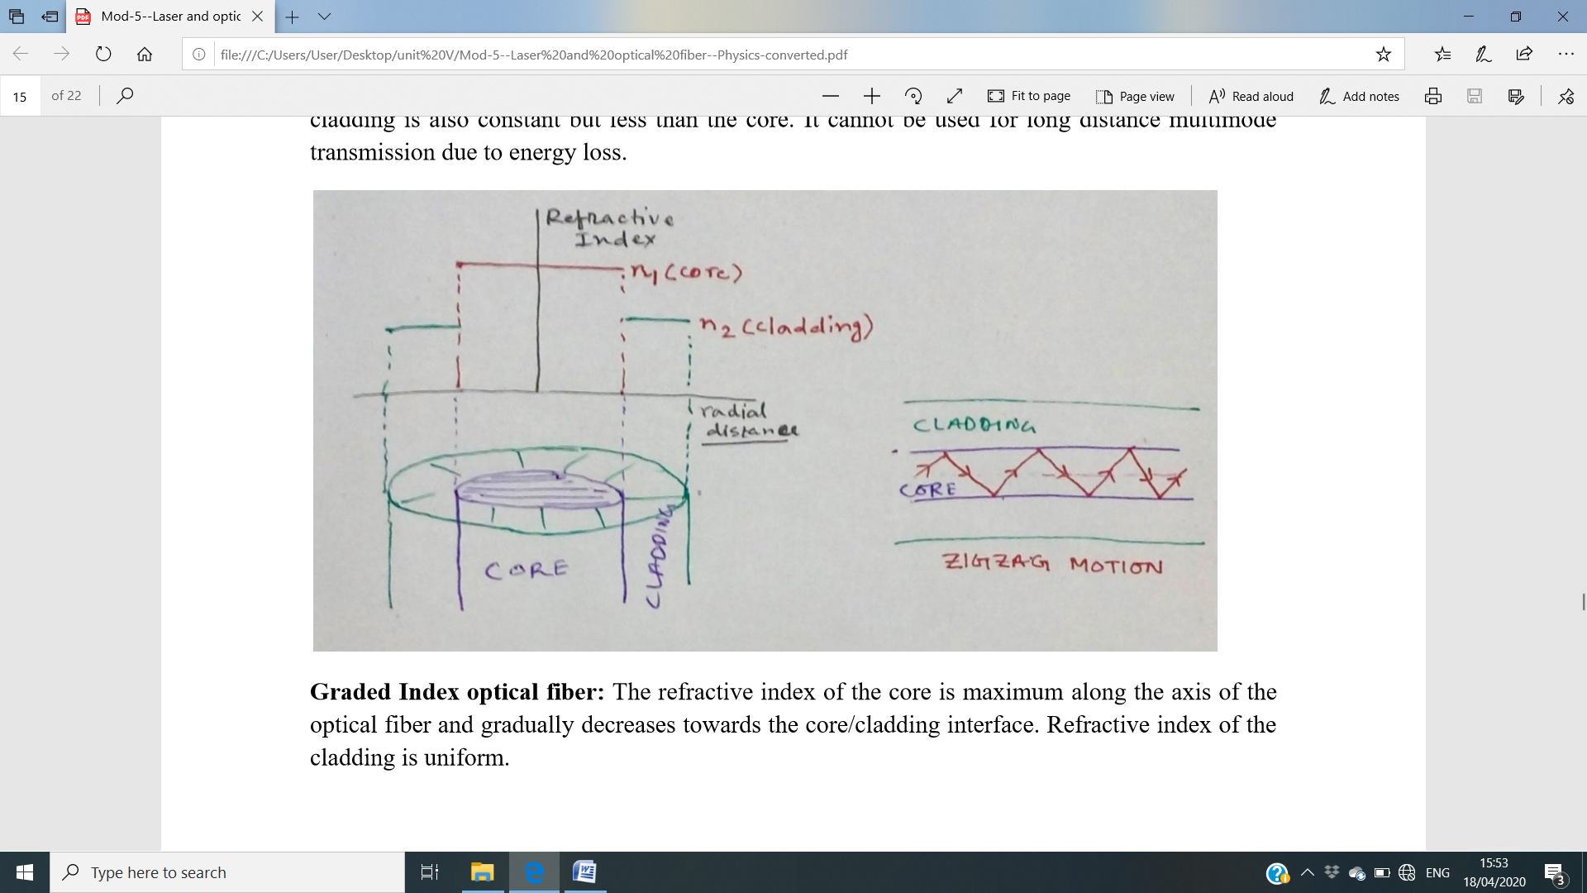

**Graded Index optical fiber:** The refractive index of the core is maximum along the axis of the optical fiber and gradually decreases towards the core/cladding interface. Refractive index of the cladding is uniform. It is used in long distance communication. It is used in long distance communication

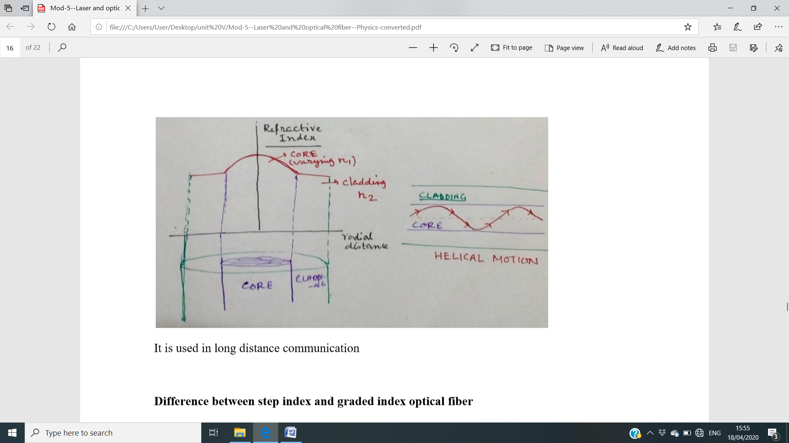

**Difference between step index and graded index optical fiber**

|  |  |
| --- | --- |
| **Step index** | **Graded index** |
| Structure |  |
| Schematic diagram |  |
| Light follow zigzag path | Light follow helical path |
| Used in short distance communication | Used in long distance communication |
| More dispersion of light rays | less dispersion |

**Types of optical fiber based upon use**: (i) Single mode (ii) multimode optical fiber

**Single mode optical fiber** can carry only one electromagnetic field configuration (signal). Multimode optical fibers can carry more than one electromagnetic field configuration (signal).

Single mode step index fiber: A single mode step index fiber consists of a very thin core of uniform refractive index (R.I) surrounded by Cladding of R.I lower than that of Core. Since the core size is small the numerical aperture is also small. They accept light from laser source. They are used in long distance communications (telephony, TV broadcast systems). Low/no dispersion possibility. Product cost is high.

**Multimode step index fiber:** This is similar to single mode step index fiber with the exception that it has a larger core diameter. The core diameter is very large as compared to wavelength of light transmitted. The numerical aperture is large because of large core size. They accept light from both laser as well as from LED. They are used in data links, Local area network (LAN). Dispersion possibility.. Product cost is low.

**Graded index multimode fiber (GRIN fiber):** In this type of optical fibers, R. I. of the Core varies with distance from the fiber axis. It has high R.I. at center and R.I. falls rapidly as radial distance increases from the axis. In GRIN fibers the acceptance angle and numerical aperture diminishes with radial distance. They accept light from both laser as well as from LED. They are used for medium distance communication for example telephone link between central offices in a small geographic area.

**Numerical aperture:**

Numerical Aperture is defined as the sine of the acceptance angle of a waveguide or fiber (the Sine of half of the angle of fiber’s light acceptance cone., i.e. NA = Sin θa where θa, is called acceptance cone angle).

The propagation of light through an optical fiber is depicted in the **figure**.

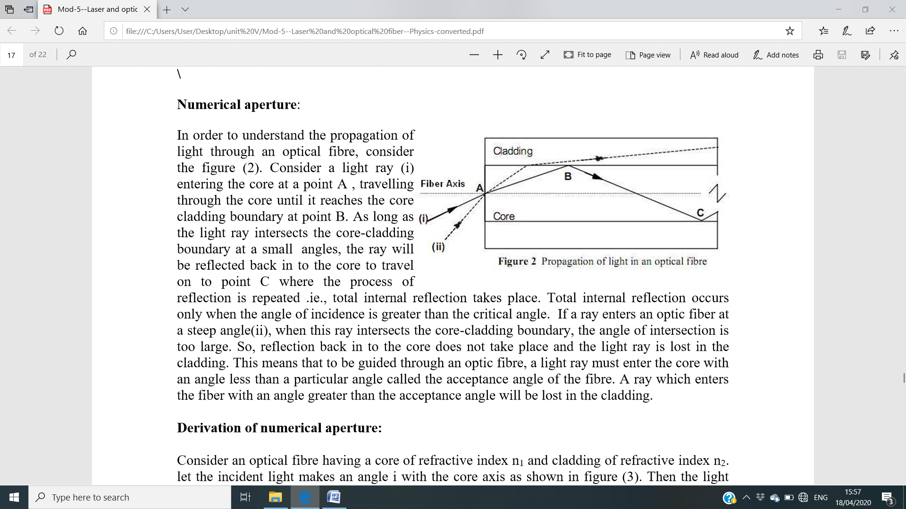

**Fig.:** propagation of light waves in the optical fiber

Consider a light ray **(i)** entering the core at a point **A**, travelling through the core until it reaches the core cladding boundary at point **B**. As long as the light ray intersects the core-cladding boundary at a small angles, the ray will be reflected back in to the core to travel on to point **C** where the process of reflection is repeated .ie., total internal reflection takes place. Total internal reflection occurs only when the angle of incidence is greater than the critical angle. If a ray enters an optic fiber at a steep angle **(ii)**, when this ray intersects the core-cladding boundary, the angle of intersection is too large. So, reflection back in to the core does not take place and the light ray is lost in the cladding. This means that to be guided through an optic fiber, a light ray must enter the core with an angle less than a particular angle called the acceptance angle of the fiber. A ray which enters the fiber with an angle greater than the acceptance angle will be lost in the cladding.

**Derivation of numerical aperture**: Consider an optical fiber having a core of refractive index **n1** and cladding of refractive index **n2**. Let the incident light makes an angle i with the core axis as shown in the **figure** as below.

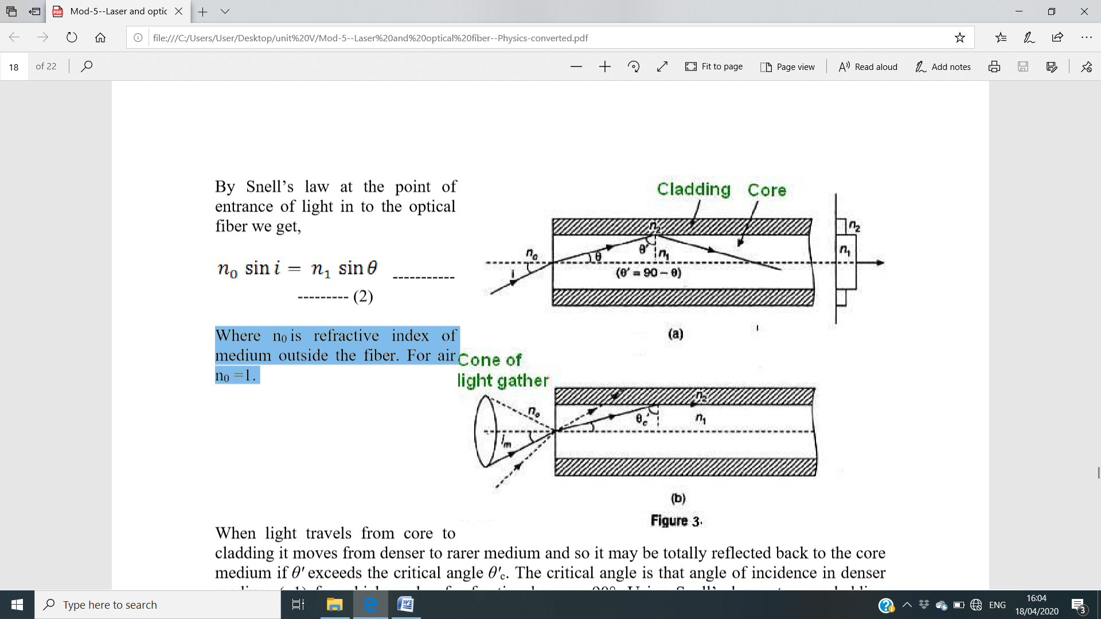

The light gets refracted at an angle **θ** and fall on the core-cladding interface at an angle where,

$θ^{'}=(90-θ)$ (1)

By **Snell’s law** at the point of entrance of light in to the optical fiber we get,

$n_{0}\sin{i}=n_{1}\sin{θ}$ (2)

where **n0** is refractive index of medium outside the fiber. For air **n0** =1.

When light travels from core to cladding it moves from denser to rarer medium and so it may be totally reflected back to the core medium if **θ'** exceeds the critical angle **θ'c**. The critical angle is that angle of incidence in denser medium (**n1**) for which angle of refraction become 90°. Using Snell’s laws at core cladding interface,

$n_{1}\sin{θ_{c}^{'}}=n_{2}\sin{90}$ (3)

$\sin{θ_{c}^{'}}=\frac{n_{2}}{n_{1}}$ (4)

Therefore, for light to be propagated within the core of optical fiber as guided wave, the angle of incidence at core-cladding interface should be greater than **θ'c.** As **i** increases, **θ** increases and so **θ'** decreases. Therefore, there is maximum value of angle of incidence beyond which, it does not propagate rather it is refracted in to cladding medium (see the **Fig.**).

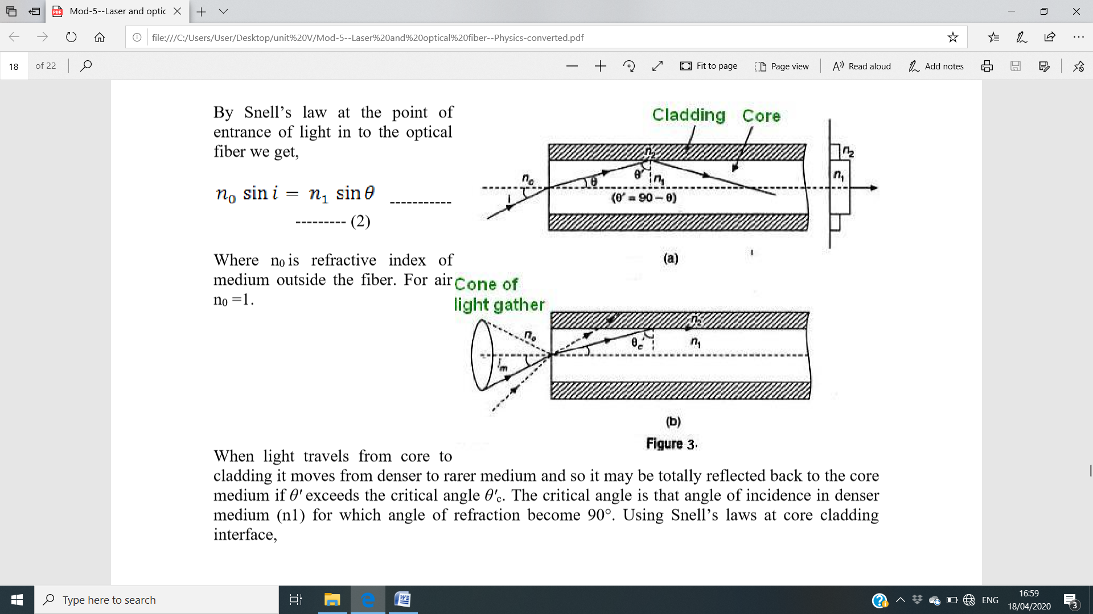

This maximum value of **i** say **im** is called maximum angle of acceptance and **n0** **sin im** is termed as the numerical aperture (**NA**). From equation (2);

${NA=n}_{0}\sin{i_{m}}=n_{1}\sin{θ}=n_{1}\sin{ (90-θ_{c}})$ (5)

${NA=n}_{1}\cos{θ_{c}^{'}}=n_{1}\sqrt{1-\sin^{2} θ_{c}^{'}}$ (6)

Putting the value of $\sin{θ_{c}^{'}}=\frac{n_{2}}{n_{1}}$, we have

$NA=n_{1}\sqrt{1-\frac{n_{2}^{2}}{n_{1}^{2}}}$ (7)

Therefore,

$NA=\sqrt{n_{1}^{2}-n_{2}^{2}}$ (8)

The significance of **NA** is that light entering in the cone of semi vertical angle **im** only propagate through the fiber. The higher the value of **im** or **NA** more is the light collected for propagation in the fiber. Numerical aperture is thus considered as a light gathering capacity of an optical fiber. It is determined by acceptance angle **im** (It is the maximum angle for which incident ray undergo total internal reflection at the core-cladding interface and stays in the core of the optical fiber).

**Source of Attenuation in optical fibers:**

(i) Energy absorbed in lattice vibration.

(ii) Energy absorbed by impurities.

(iii) Scattering of light due to local variation in refractive index.

**Application of optical fiber:**

*Communication:* High speed, high intensity and low loss data transmission.

*Medical field:* Diagnostic instruments- retinal treatment.

*Industry:* Laser is carried through optical fibers for cutting, drilling, and welding.

*Fiber Optic Communication Link (FOCL):* used to send signal over long distance which comprises of transmitter, fiber optic cable and receiver?

**Fiber optics communication:** It is a method of transmitting information from one place to another by sending pulses of infrared light through an optical fiber. The light forms an electromagnetic carrier wave that is modulated to carry information. The fiber is preferred over electrical cabling when high bandwidth, long distance, or immunity to electromagnetic interference are required. This type of communication can transmit voice, video, and telemetry through local area networks, computer networks, or across long distances.

**Figure** (see below) shows the schematic diagram of a fiber optic communication system. The major components of an optical fiber communication system are

1. Optical transmitter
2. Optical fiber
3. Optical receiver

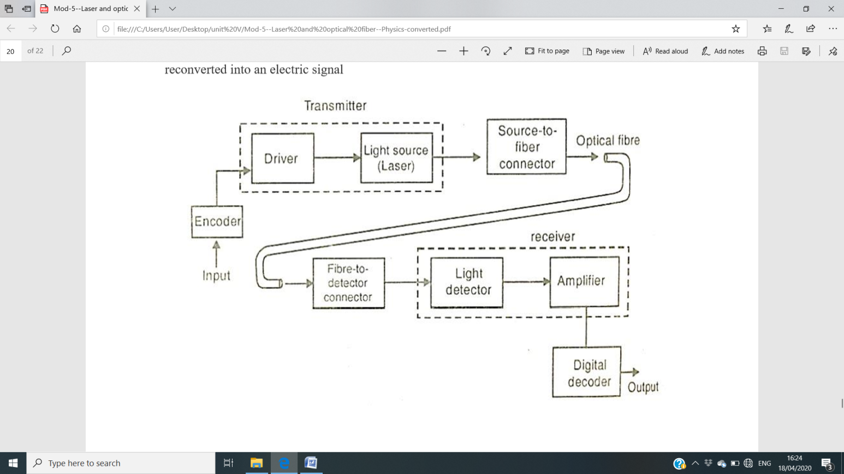

**Principle**: Basically, a fiber optic system converts an electrical signal to an infrared light signal. This signal is transmitted through an optical fiber. At the end of the optical fiber, it is reconverted into an electric signal.

**Working**:

**1.** The Encoder (an electric circuit where in the information is encoded into binary sequences of zeros and one) encodes the information in the binary sequence zeros and ones. In the light wave transmitter each ‘one’ corresponds to an electrical pulse and ‘zero’ corresponds to an absence of a pulse. These electrical pulses are used to turn a light source on and off very rapidly. The driver converts the incoming electrical signal into a form that will operate with the light source.

**2.** These electrical pulses are used to turn a light source on and off rapidly.

**3.** The optical fiber acts as a wave guide and transmits the optical pulses towards the receiver, by the principle of total internal reflection.

**4.** The light detector receives the optical pulses and converts them into electrical pulses. These signals are amplified by the amplifier.

**5.** The amplified signals are decoded by the decoder.

**Advantages of FOCL (Fiber optics communication link):**

*high information density* (fiber optic cabling provides a much higher bandwidth)

*light weight and cheaper*

*much lower levels of signal attenuation or loss*

*high speed data transmission*

*no leakage*: secured communication (fiber optics do not suffer from stray interference pickup that occurs with coaxial cabling).

**Model Questions:**

1. What is an optical fiber? Sketch the different parts of an optical fiber.
2. State the principle of an optical fiber.
3. Why should clad glass have less refractive index than the core glass?
4. Mention the role of cladding in an optical fiber.
5. What is a step index optical fiber? Draw the refractive index profile of it.
6. What is a graded index optical fiber? Draw the refractive index profile of it.
7. Write down differences between step index optical fiber and graded index optical fiber.
8. Write down the differences between single mode optical fiber and multimode optical fiber.
9. Which of the optical fibers, among single mode and multimode optical fibers, is used for

long distance communication and why?

10. Draw the path of rays in the graded index optical fiber.

11. Define numerical aperture of an optical fiber.

12. What are the disadvantages of using fiber optic communication system?

13. Mention the important applications of optical fiber.

14. Schematically show the basic elements of FOCL.

15. What is the principle of optical fiber? Draw a neat ray diagram showing the principle of

Optical fiber. Obtain an expression for critical angle of incidence at core-cladding interface

in terms of their refractive indices.

16. What are the advantages of using fiber optic communication system?

17. What is numerical aperture of an optical fiber? Derive an expression for numerical aperture

of a step index optical fiber.

**Numerical**

**1.** If the acceptance angle of an optical fiber is 68.160, find the numerical aperture. If cladding has refractive index of 1.52, what is the refractive index of the core?

**2.** What is the critical angle of a ray of light in a step index optical fiber for which refractive index of the core is 1.53 and that of cladding is 2.5 % less than that of the core.

**3.** The refractive index of the core and cladding of a step index optical fiber are 1.52 and 1.41 respectively. Calculate its critical angle, Numerical aperture and the acceptance angle.

**4.** If the acceptance angle for a given fiber is 68.160, calculate the maximum entrance angle and numerical aperture. If the cladding glass has a refractive index of 1.52, calculate the refractive index of the core glass.

**5.** If the acceptance angle for a given fiber is 630, calculate the maximum entrance angle and numerical aperture.